21BDS0340 – Abhinav Dinesh Srivatsa

21BCE3039 – Chadalawada Siva Bala Krishna Chowdary

Embedded Systems

**Repository Links**

1. Telemetry
   1. <https://github.com/weatherman-org/telemetry>
2. Dashboard
   1. <https://github.com/weatherman-org/dashboard>
3. Model
   1. <https://github.com/weatherman-org/model>
4. Deployment (Houses complete deployment from scratch with optional building)
   1. <https://github.com/weatherman-org/deployment>

**Building the Project**

1. git clone <https://github.com/weatherman-org/deployment>
2. make build_deploy

**Model Training and Details**

Dataset API: <https://archive-api.open-meteo.com/v1/archive>

API Params:

{

"latitude": 12.9184,

"longitude": 79.1325,

"start_date": "2003-01-01",

"end_date": "2024-01-01",

"hourly": "temperature_2m,relative_humidity_2m,rain,surface_pressure,wind_speed_100m,wind_direction_100m",

"timezone": "auto",

"format": "csv"

}

Dataset Example Rows:

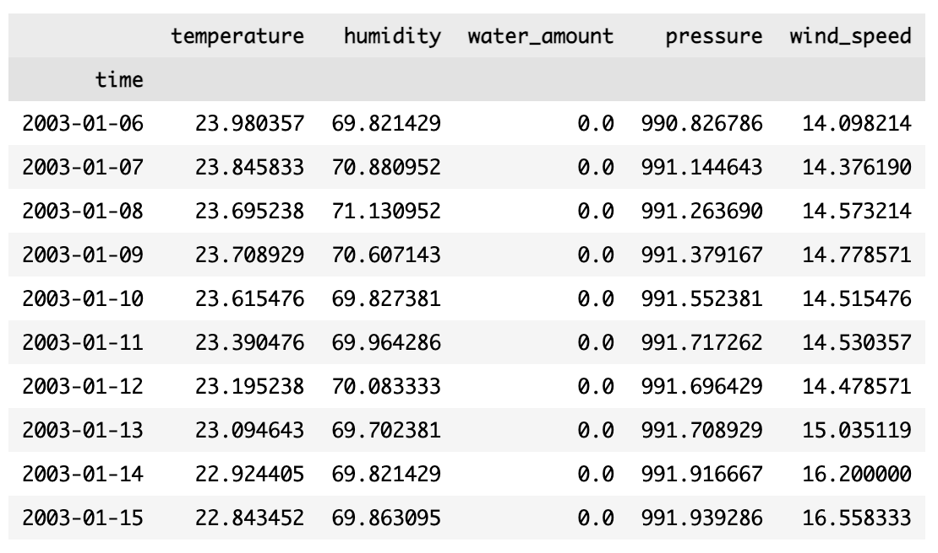

7-Day Rolling Averages of Dataset:

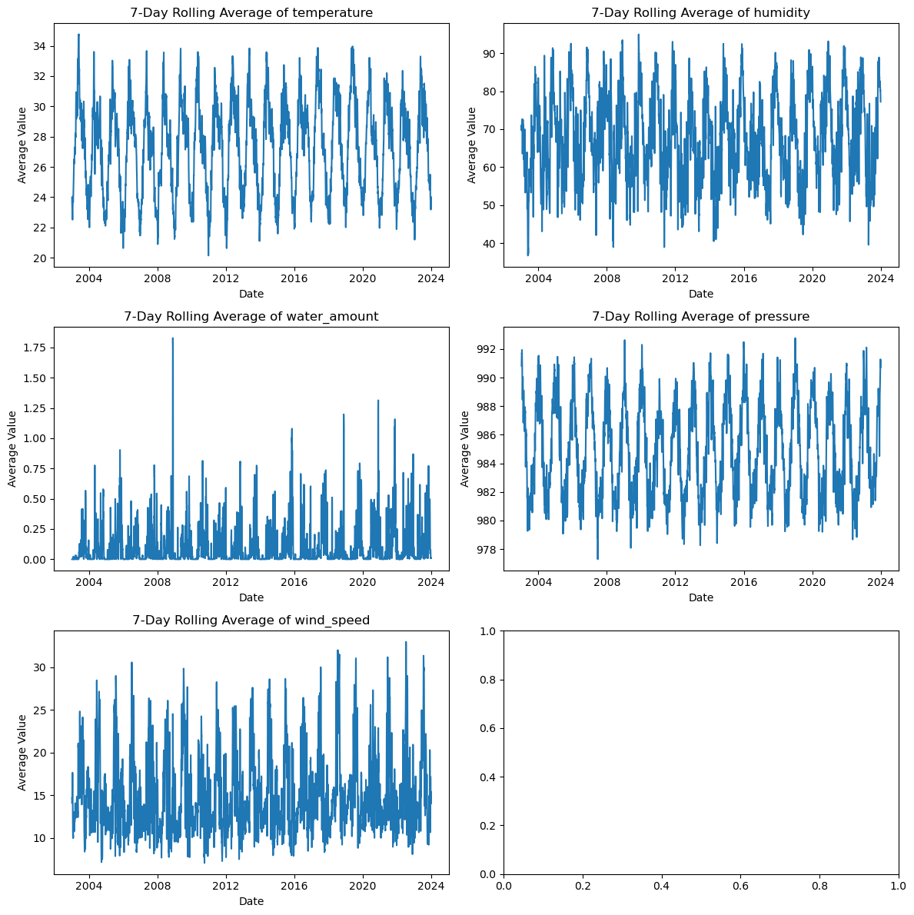

Model Prediction (Orange) vs Actual (Blue):

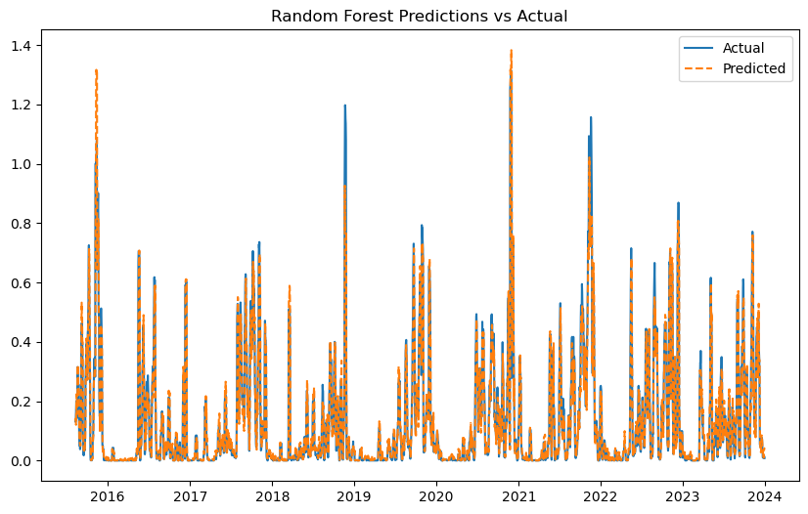

**Dashboard Views**

**Prediction Page**

**Data History Page (Top)**

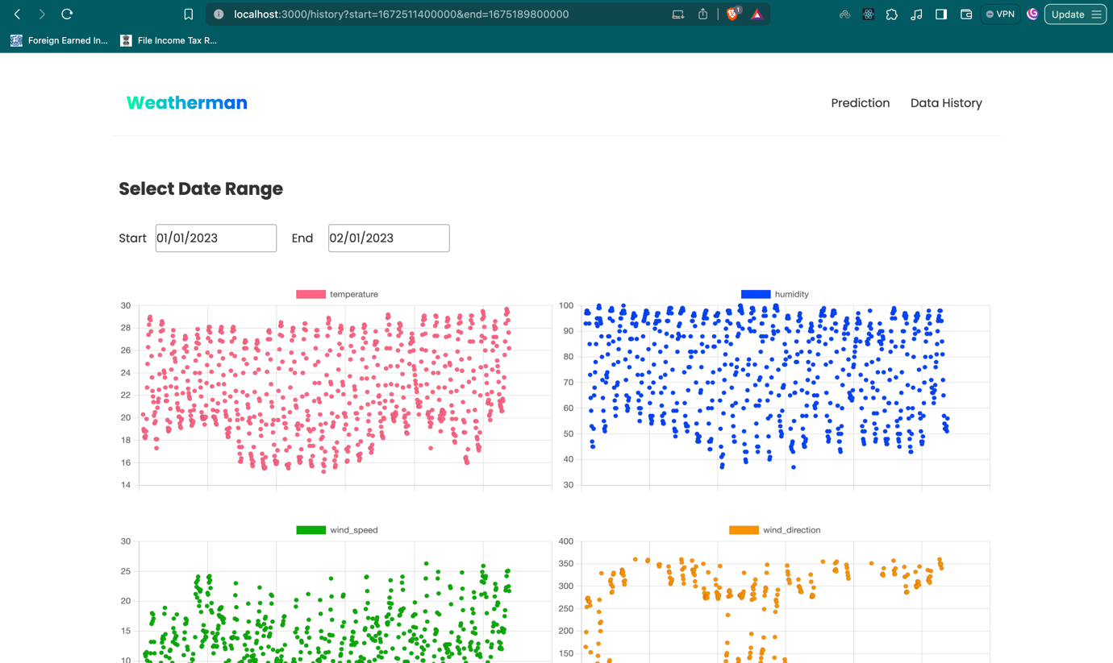

**Data History Page (Bottom)**

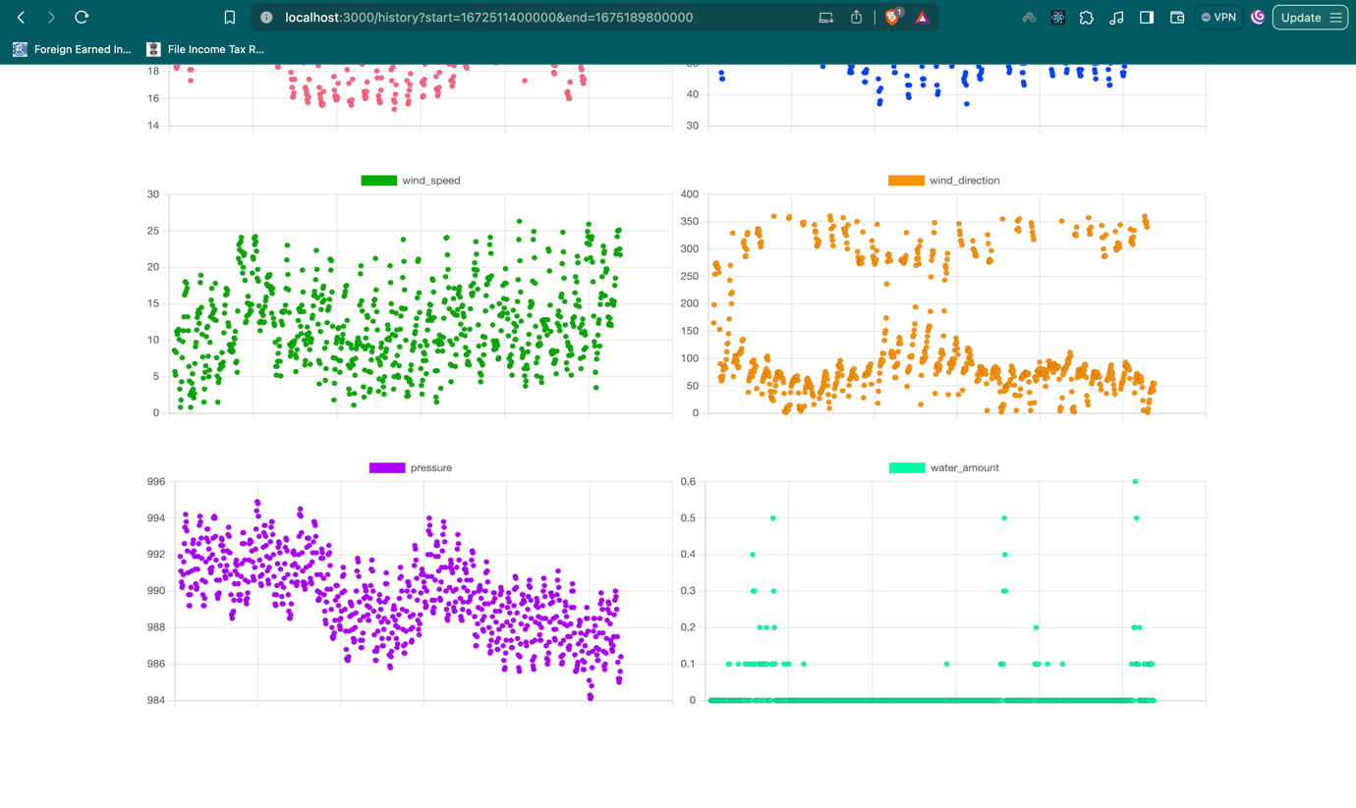

**Specific Graph Page**

**Telemetry Swagger Dashboard**

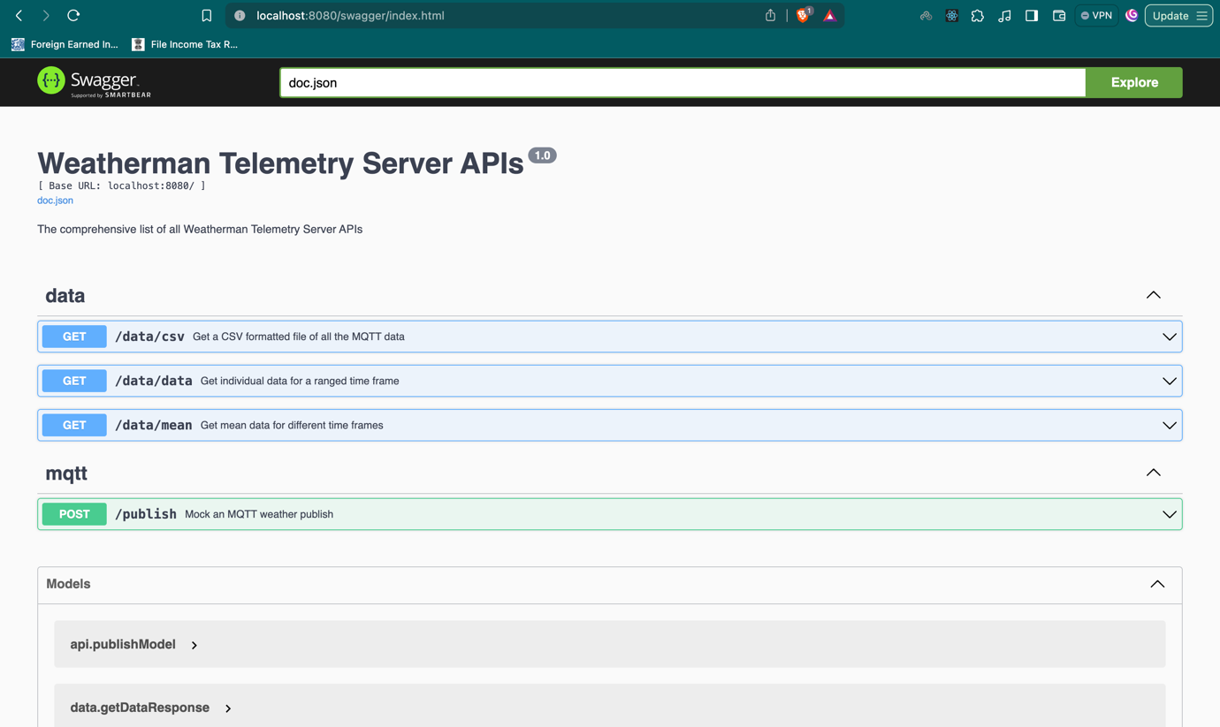

**Model Swagger Dashboard**

